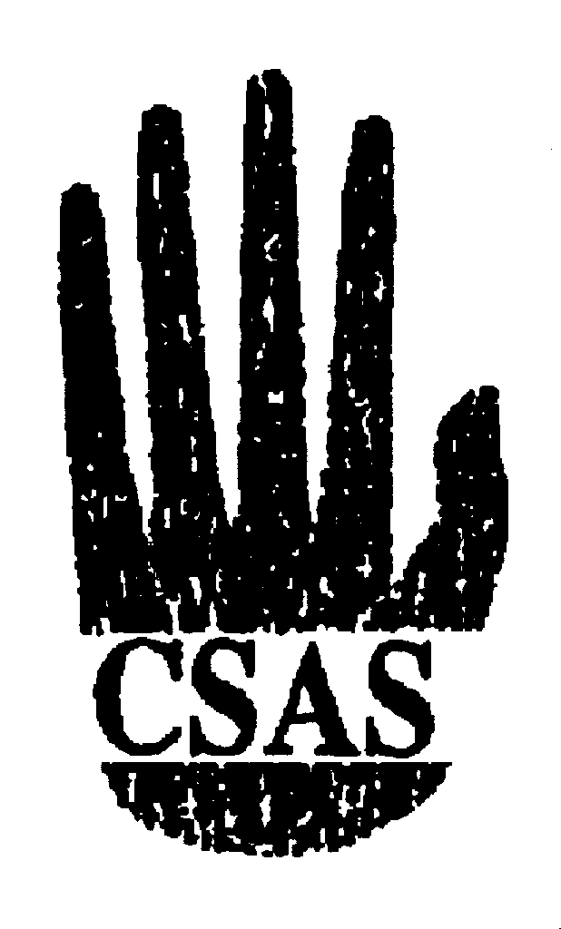
Central States Anthropological Society

Leslie A. White Award
Application Deadline
April 27, 2015

The Leslie A. White Award was established in 1983 to honor Leslie A. White’s contribution to the CSAS and to anthropology. The award was established to encourage and enable undergraduate or graduate students to pursue research and publishing in any subfield of anthropology.

Applications for the White Award should consist of the following:

A. Send to stanlaw@ilstu.edu as email attachments in either Word or PDF format:
(1) completed application form;
(2) statement (no more than 1000 words) describing why the award is sought (e.g., to offset expenses for fieldwork, travel, equipment, supplies, or food and lodging);
(3) statement (no more than 1000 words) indicating the importance of the applicant’s work to anthropology;
(4) curriculum vitae (no more than 5 pages in length).

B. No more than three letters of recommendation from faculty members and others familiar with the applicant’s scholarly work, sent either in sealed envelopes with author’s signature across the flap, or directly by referee, to
James Stanlaw
Chair, CSAS Dillingham Award Committee
Anthropology 4640
332 Schroeder Hall
Illinois State University
Normal, IL 61790

The 2015 award will be in the amount of $500.

All application materials—both electronic and mailed—must be received by April 27, 2015. Incomplete applications will not be considered. All applications will be reviewed and a decision made no later than June 29, 2015. For more information, contact Jim Stanlaw at stanlaw@ilstu.edu; or by phone at (309)-438-7690 (office) or (309)-454-2151 (home). Application forms can be found at the CSAS website, http://www.aaanet.org/sections/csas/.

2015 CSAS LESLIE A. WHITE AWARD – APPLICATION FORM

(Please type all information.)

LAST NAME ________________ FIRST NAME ________________ MI _____

INSTITUTION CURRENTLY ATTENDING:

MY MAJOR AREA OF STUDY IS:

I AM CURRENTLY (CHECK ONE)
□ freshman □ sophomore □ junior □ senior
□ master’s program □ PhD program □ ABD in PhD program

I AM CURRENTLY A MEMBER OF THE CENTRAL STATES ANTHROPOLOGICAL SOCIETY (CHECK ONE)
□ yes □ no

CURRENT CONTACT INFORMATION (valid through June 1, 2015)

Street address

City

State Zip code

Phone Email

SUMMER CONTACT INFORMATION (valid June 1, 2015 through August 15, 2015)

Street address

City

State Zip code

Phone Email

If you should be selected as a 2015 recipient, your social security number will be required.

