Central States Anthropological Society
2014 Annual Meeting

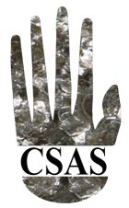
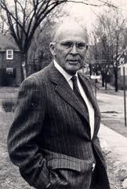

Central States
Anthropological Society
Leslie A. White Award

Application Deadline May 15, 2017

The Leslie A. White Award was established in 1983 by the estate of Raymond L. Wilder, the father of then President Beth Wilder Dillingham, a former doctoral student of White, to honor Leslie A. White’s contribution to the CSAS and to anthropology. The award was established to encourage and enable undergraduate or graduate students to pursue research and publishing in any subfield of anthropology.
Applications for the White Award should consist of the following:

A. Send to willie.mckether@utoledo.edu as email attachments in either Word or PDF format: (1) completed application form;
(2) statement (no more than 1000 words) describing why the award is sought (e.g., to offset
expenses for fieldwork, travel, equipment, supplies, or food and lodging);
(3) statement (no more than 1000 words) indicating the importance of the applicant’s work to
anthropology;
(4) curriculum vitae (no more than 5 pages in length).

B. No more than three letters of recommendation from faculty members and others familiar with the applicant’s scholarly work, sent either in sealed envelopes with author’s signature across the flap, or directly by referee, to

Willie L. McKether, Ph.D.
Chair, CSAS White Award Committee
The University of Toledo
3510B University Hall
2801 W. Bancroft Street, MS 926
Toledo, OH 43606-3390
Phone: 419.530.2260
Fax: 419.530.2116
willie.mckether@utoledo.edu

The 2017 award will be in the amount of $500.

All application materials—both electronic and mailed—must be received by May 15, 2017. Incomplete applications will not be considered. All applications will be reviewed and a decision made no later than August 30, 2017. For more information, contact willie.mckether@utoledo.edu
; (419) 530-2260. Application forms can be found at the CSAS website, http://www.aaanet.org/sections/csas/.

