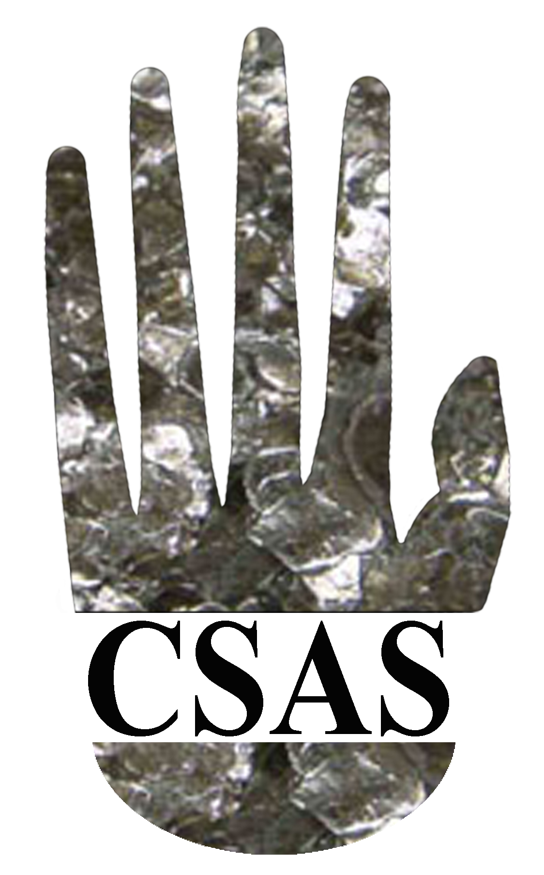
CALL FOR PARTICPATION

Central States Anthropological Society

Celebrate a century of Spring Soirees(!)
in a virtual meeting on April 24-25, 2021

Our annual get-together of the Central States Anthropological Society will be held virtually on April 24 and 25, 2021. You won’t have to travel far. Please join us from the comfort of your couch … And you won’t have to pay very much, as registration is FREE. (But you’ll have to provide your own snacks at break …).

Faculty, students, independent scholars, and practitioners are invited to present or hear papers, and participate in workshops and roundtables, in all five fields of anthropology, including applied subdisciplines. This meeting also offers an opportunity for anthropologists from throughout the greater Central States area (like, from California to Connecticut), from institutions large and small, to meet, talk, and network together in a welcoming and genial professional environment.

If you wish to present an individually-volunteered paper, participate in an organized session or propose a workshop, please submit an abstract (of about 250 words). The CSAS encourages student participation in any of these venues. They are also invited to enter their submitted papers in our undergraduate and graduate prize competitions.

New this year will be the hosting of “seminar sessions,” which will be of particular interest to faculty members and advanced graduate students. They will offer an opportunity to get helpful feedback on a current project, such as book, thesis, journal article, or grant application. In a seminar session, papers can be presented to potential audience members ahead of time. During the session, the author(s) will summarize their work for some ten or fifteen minutes, followed by a moderated discussion. These sessions can be up to an hour.

The contact person for CSAS 21 is Jim Stanlaw (stanlaw@ilstu.edu; 309-454-2151) at Illinois State University. He is available to discuss any paper, seminar session, workshop, or organized symposia that members may wish to propose.

Again, there is no registration fee for this meeting; membership in the CSAS is encouraged but not mandatory. However, advanced registration is required (see the form on the following page). If you wish to participate formally, the deadline for abstract/proposal submissions is April 2, 2021. The general registration deadline is April 16, 2021.

Registration Form
CSAS 2021
April 24 and 25, 2021
(no registration fee required)

Name: __________________________________________________

Affiliation:
university/college: __________________________________________

department: _______________________________________________

registration category:

Faculty member: _____ independent scholar _____

Ph.D. graduate student _____ MA graduate student _____

undergraduate student _____ other ___________________

email address(s): _______________________________________________________________

membership category: CSAS member (not required) _____ non-CSAS member _____

participation level:

attendee only _____ volunteered paper _____

organized panel _____ workshop/roundtable _____

seminar session _____ other organized format _____

If participating in any of the above activities (besides being an attendee) please attach an abstract or proposal of up to 250 words to the registration form. These will be due by April 2, 2021, and should be in a Microsoft Word or plain-text document (*.doc, *docx, or *.rtf). If you are a student please have a faculty member or supervisor also send an e-mail of support. Otherwise, general attendees are asked to register by April 16, 2021.

Email all materials to Jim Stanlaw at stanlaw@ilstu.edu

If you need to send in a hard copy, please mail it to:

James Stanlaw
CSAS 2021
Anthropology 4640
332 Schroeder Hall
Illinois State University
Normal, IL 61790

